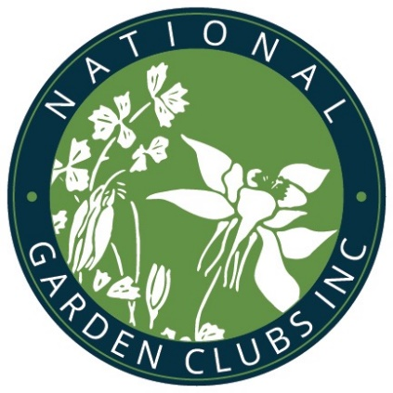
NGCs Gardening School: Series 12, Course 4 Sponsored by Chinook District of Garden Clubs in Washington State Federation of Garden Clubs

January 12-13, 2021

Refer to tri-fold brochure for details and schedule

Presented virtually via via

Topics, Instructors:

Plant Classification and Nomenclature, Bess Bronstein

Specialized Styes of Gardening, Alison Johnson

Pruning Technique, Laura Matter

Plant Identification, Bess Bronstein

Growing Woody Ornamentals, Christina Pfeiffer

Native Trees and Shrubs, Laura Matter
Permitted Equipment (circle one): Desktop or Laptop computer, Tablet or iPad
Operating system*: (circle one) Microsoft Windows, Apple MacOS, Apple iOS on iPad, Android on Tablet). Smartphones not permitted unless it’s for “Hotspot” connectivity), Zoom 5.0.
*Meets Zoom requirements
Participants must have a desktop or laptop computer or tablet with audio and video capacity and must attend a test;/practice session to run-through their ability to use zoom and do a test check the week before. Date to be announced with registration confirmation.
Registration Form:
Name

Club____________________________________District_______________________________________

Address
Street City State Zip

Email Phone__________________________________
Please indicate your registration option:
- Full course with exam $75
- Full course, no exam $70
- Full course, refreshing $75

Make checks payable to: Chinook District
Mail registration and checks to:
Registrar Marilee Capodanno
1144 S. 229th Pl.
Des Moines, WA 98198
Required reading: The National Gardener. Guide for Students and Consultants (Student Guide Revised 2/2019) available on NGC website and provided in student packets with course outlines.

